**LAB 7 REPORT**

**INTRODUCTION:**

In this lab we are going to create an instance in EC2 of AWS and we will deploy node app in it. EC2 means Elastic compute cloud, which allows users or developers can rent the virtual server to develop and deploy their own applications.

**PRE REQUISITES:**

* Aws Account.
* PUTTY(if you would like to use it)
* A node app.

IMPLIMENTATION:

* First we need a AWS account to do this deployment, create a AWS account and login to AWS console and then in the services page,click on EC2,this is where you can deploy your app into a instance.
* After opening the EC2 service, launch a instance, in this you have to select a server to launch your app,usually we would select the ubuntu server as it is pretty good to use.

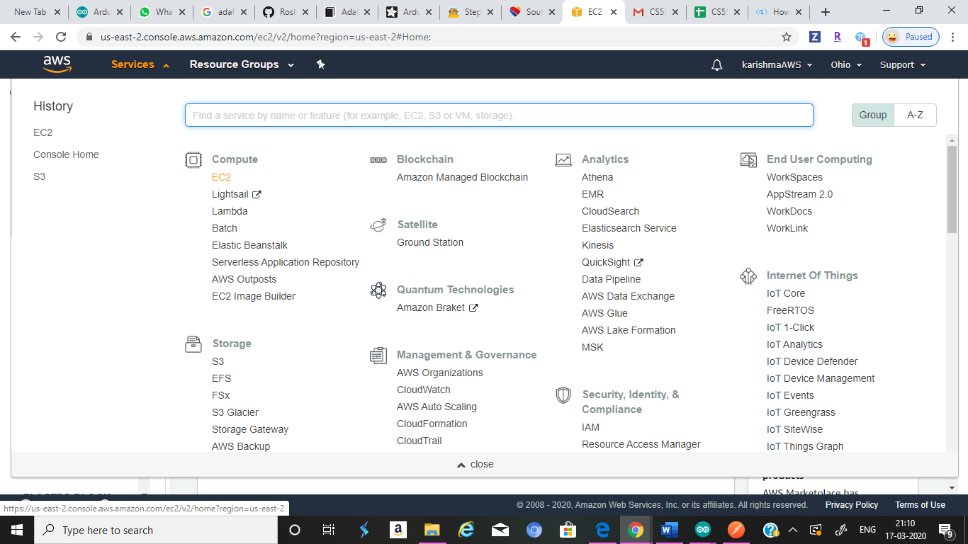

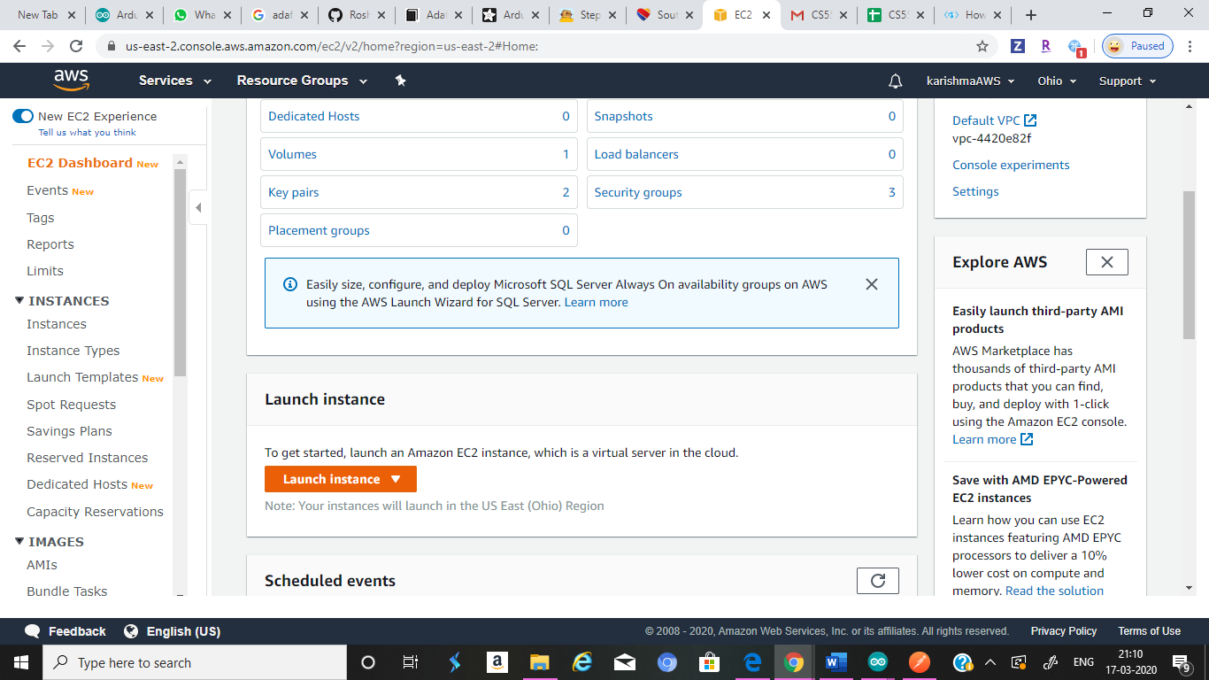

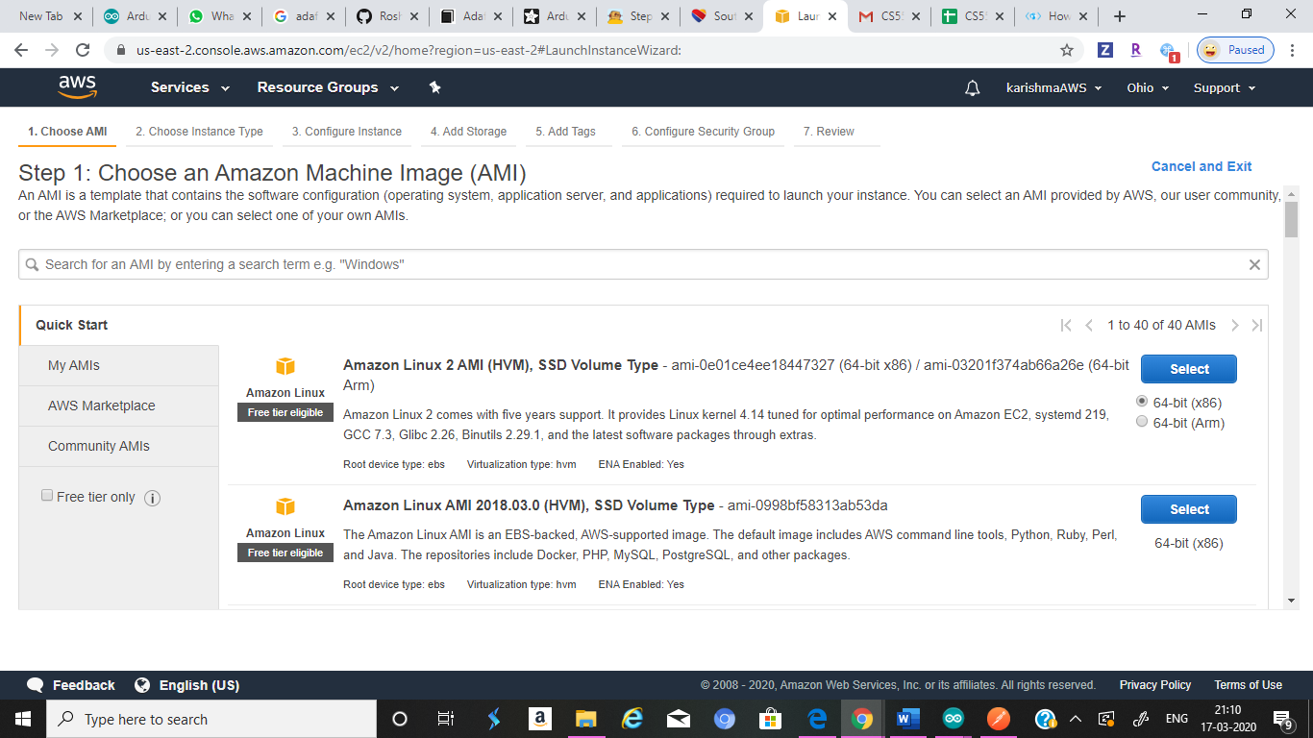

* Later, select a free tier in that,actually it is automatically selected.now you have review and launch the instance.

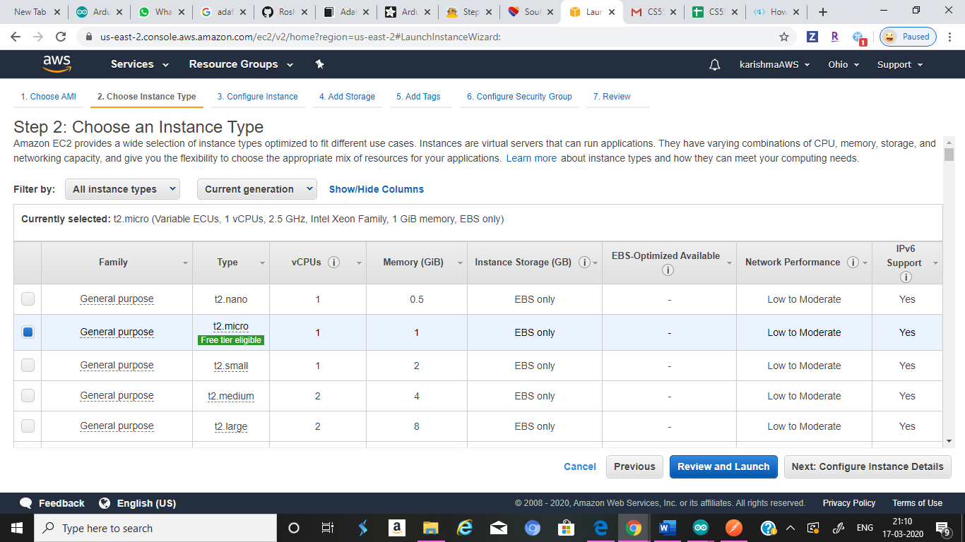

* The later page is about selecting the port,generally it is selected as 22 port,you can just use it, later launch the instance.

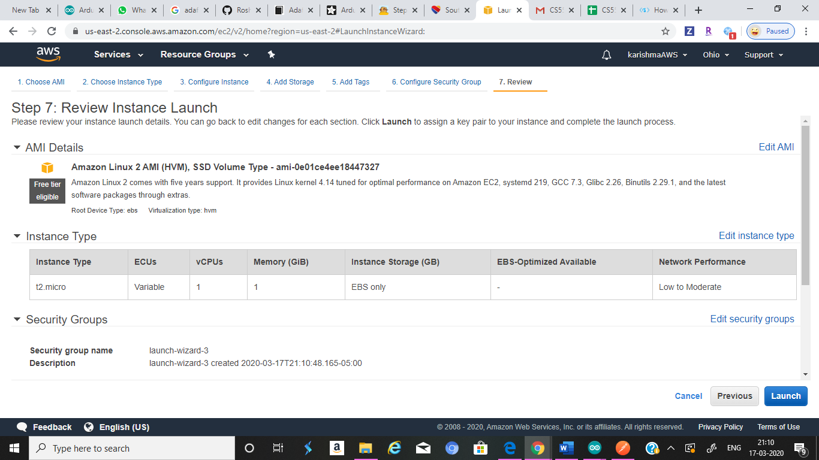

* Later, you have to create a key that can use to connect the instance to the server and download it and save in your local machine.

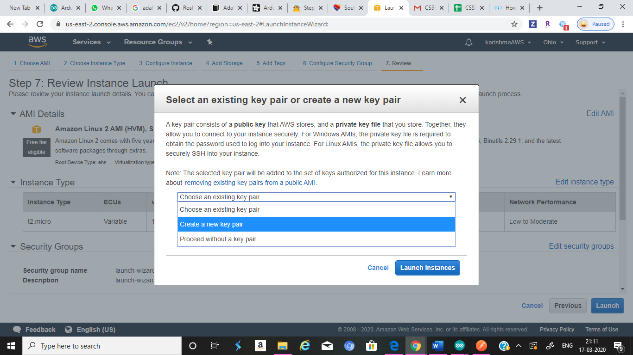

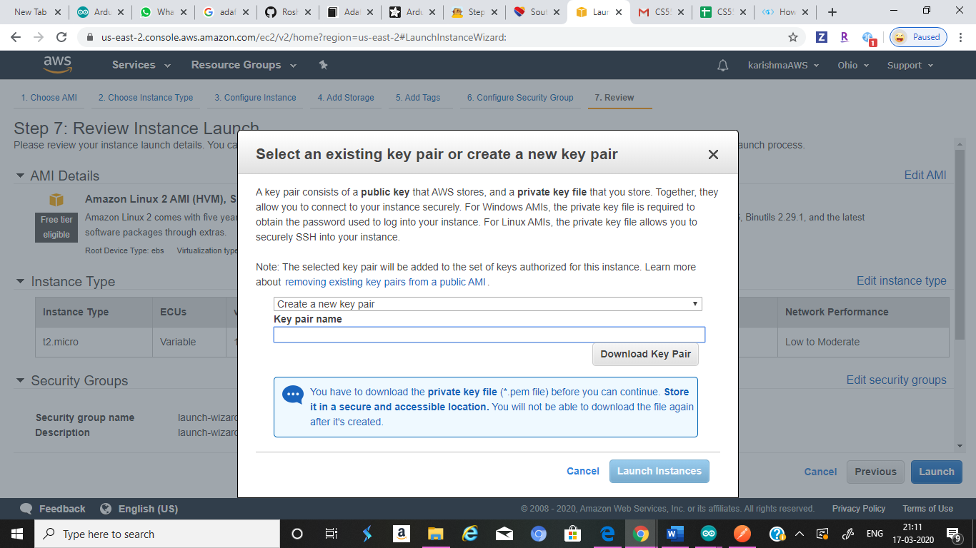

* Now,you have to connect the instance for that we will do SSH,you can connect using putty, or you can connect it from you command window too.
* You have to give the ip address of host to connect this from putty, to connect from command window, we have to give the key over there,for this you have to remember the file path of the key that you created.

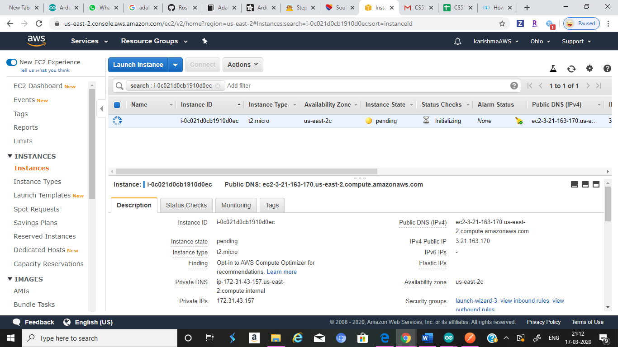

* After creating the key, you have to install node.js into the server, and we have to give the post and get commands, that when you request a get command or when you request for post it will show the app file that attached with request.
* After this we should run that app,it will assign a port to it and you can view it by giving that ip address in the instance to browser to access the information in app,by deploying it.
* in order get the output even though the command window is not opened we have to run the server continuously,for that we have to run the node in background.

OUTPUT IMAGES:

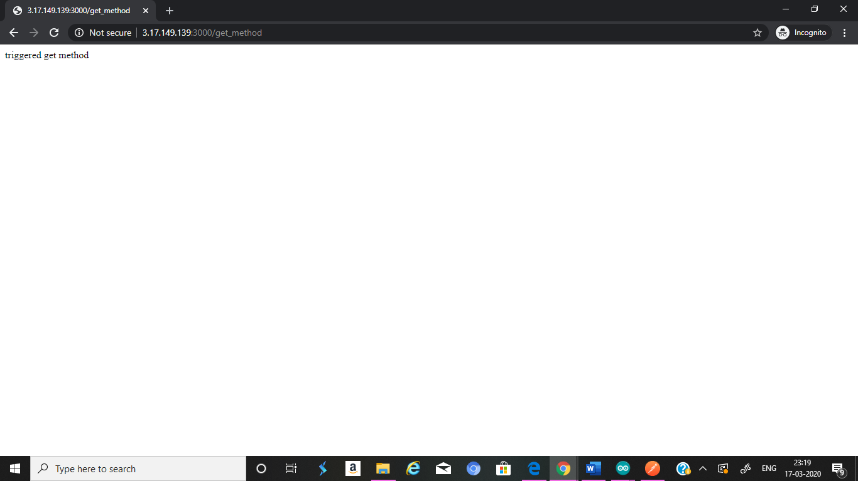

When get method is called

.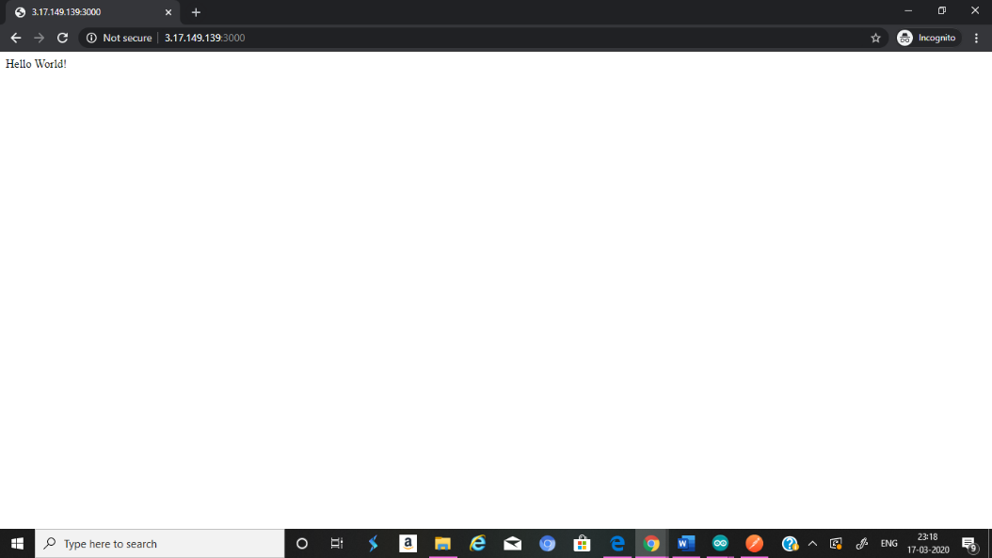

**When app is deployed**

**LIMITATIONS:**

* Creating instance is easy,but we hav to select the free tier or it will cost you fro using it.
* You have to stop running the instance when you are not using it,because AWS only allows you to use it for certain limited time.

**CONCLUSION:**

Through this assignment we have learnt how to use EC2, how to create a instance in EC2 and how to deploy a node app in EC2.

TEAM MEMBERS:

**Karishma yallanki class id: 29**

**Tejaswi guturu class id: 16**